PROJECT REPORT
Visualizing Housing Market Trends: An Analysis of Sale Prices and Features using Tableau
Team Members: Masa Nani (Team Lead) • Gabbi Nithya Sree
Date: 13 July 2026
TABLE OF CONTENTS
1. Introduction
1.1 Project Overview
1.2 Purpose
2. Ideation Phase
2.1 Problem Statement
2.2 Empathy Map Canvas
2.3 Brainstorming
3. Requirement Analysis
3.1 Customer Journey Map
3.2 Solution Requirement
3.3 Data Flow Diagram
3.4 Technology Stack
4. Project Design
4.1 Problem Solution Fit
4.2 Proposed Solution
4.3 Solution Architecture
5. Project Planning & Scheduling
5.1 Project Planning
6. Functional and Performance Testing
6.1 Performance Testing
7. Results
7.1 Output Screenshots
8. Advantages & Disadvantages
9. Conclusion
10. Future Scope
11. Appendix
1. INTRODUCTION
1.1 Project Overview
The project “Visualizing Housing Market Trends: An Analysis of Sale Prices and Features using Tableau” analyses approximately 21,609 residential sale records to uncover the key factors that drive housing prices and sales trends. Using Tableau Public as the primary visualization tool, the project builds an interactive Dashboard and a guided Story that examine how sale price relates to house features such as bedrooms, bathrooms, living area and overall grade, as well as renovation status, house age, location (zipcode group) and waterfront view.
The completed solution — the “Comprehensive House Data Analysis” dashboard — is published directly to Tableau Public, requiring no custom website or server infrastructure. It gives home buyers, real estate agents and housing market analysts a single, openly accessible interface to explore price-driving patterns through interactive filters and a narrated story.
1.2 Purpose
Home buyers, sellers and real estate agents often lack a structured way to judge whether a house's asking price genuinely reflects its size, condition, age and location. Historical sales data is spread across thousands of property records with dozens of features, making manual analysis difficult and leaving pricing, buying and selling decisions largely based on guesswork rather than data-driven evidence.
The purpose of this project is to transform this raw housing sales data into clear, interactive visual insights so that:
- Home buyers can judge whether a listed price genuinely reflects a home's features, condition and location.
- Real estate agents can back pricing and valuation recommendations with data rather than guesswork.
- Housing market analysts can quantify the effect of renovation, age, waterfront view and location on sale price.
- All stakeholders can access these insights freely, without installing any software, via Tableau Public.
2. IDEATION PHASE
2.1 Problem Statement
Following the “I am / I'm trying to / But / Because / Which makes me feel” template, two core problem statements were defined for the project's primary personas:
Persona | Problem Statement
Real Estate Agent (PS-1) | I'm trying to understand how house features such as size, bedrooms, bathrooms, location and renovation status influence sale price, so I can advise clients on fair pricing and marketing strategy. But historical sales data is spread across thousands of individual property records with dozens of features, making it difficult to interpret manually. Because there is no centralized dashboard that summarizes price trends against house features, location and condition, this makes pricing recommendations end up based on guesswork rather than data-driven evidence.
Housing Market Analyst (PS-2) | I'm trying to analyze how sale price varies with house features (bedrooms, bathrooms, living area, lot area, floors, overall grade, age, renovation status, waterfront view) and location, using interactive visualizations. But the raw dataset contains over 21,000 property records across 34 fields, which is difficult to explore and interpret without proper visualization tools. Because manual analysis of a dataset this large is time-consuming, meaningful price-driving patterns are easily missed, which is inefficient since valuable insights about the housing market may be overlooked.
Problem to Solution Flow:
Raw Housing Dataset → Data Cleaning & Feature Transformation → Tableau Dashboard & Story → Housing Market Insights → Better Buying, Selling & Pricing Decisions
2.2 Empathy Map Canvas
An empathy map was built around the primary user persona — a prospective home buyer comparing multiple property listings and trying to judge whether an asking price is fair given the home's size, condition, age and location. This helped the team view the housing market from the user's own perspective.
Quadrant | Key Observations
Thinks | Wonders whether the asking price genuinely reflects size, condition and grade; weighs whether a renovation or waterfront-view premium is worth the cost; questions how house age affects future maintenance; considers a smaller home in a better zipcode versus a larger home further out.
Sees | Very different sale prices for houses with similar bedroom/bathroom counts; listings that highlight recent renovations versus none at all; certain zipcode groups consistently priced higher; inconsistent grading and condition ratings across similar homes.
Says | “I want to know if this price matches similar homes nearby before I make an offer.” “A renovated home should genuinely be worth more — but by how much?” “Living area and lot size matter more to me than just the bedroom count.” “I'd pay more for a waterfront view, but only if the rest of the price makes sense.”
Does | Compares sale price, living area, lot area and grade across listings side by side; checks age, renovation history and years since renovation before shortlisting; filters by zipcode group and location; weighs waterfront view and condition against the final asking price.
Pains | Frustrated when price does not align with the home's size, condition or features; finds it tedious to manually compare dozens of listings across many features; unsure whether a renovation genuinely adds long-term value; concerned about hidden long-term costs of an older, un-renovated house.
Gains | Values a transparent, side-by-side comparison of price against house features; wants confidence that price genuinely reflects true condition and location value; appreciates seeing how renovation, age and waterfront view move sale price; enjoys filtering and comparing homes quickly by budget and preferred features.
User Needs & Opportunities:
- A clear view of how price relates to core features — bedrooms, bathrooms, living area and lot area — rather than a single asking figure.
- Visibility into whether renovation status and years since renovation genuinely affect resale value.
- Insight into how location (zipcode group) influences typical sale prices in an area.
- Confidence that a home's grade, condition and age are fairly reflected in its price.
2.3 Brainstorming
The team — Masa Nani (Team Lead) and Gabbi Nithya Sree — followed a structured brainstorming and idea-prioritization process (staying on topic, encouraging wild ideas, deferring judgment, listening to others and going for volume) to move from an open problem space to a focused project plan.
Ideas were shared, clustered into four themes, and each theme assigned an owner:
- Cluster A — Data Collection & Preparation (Masa Nani): sourcing the dataset, cleaning and standardising raw data, studying the grade/condition-vs-price relationship.
- Cluster B — Price & Feature Relationship Analysis (Gabbi Nithya Sree): zipcode segmentation, renovation-status effects, waterfront-view premium and house-age impact.
- Cluster C — Dashboard & Visualization Design (Masa Nani): interactive dashboard with KPI cards and filters, bar/pie charts for house-age distribution.
- Cluster D — Story, Deployment & Documentation (Gabbi Nithya Sree): Tableau Story narrative, publishing to Tableau Public, summary insights write-up.
The clustered ideas were then plotted on an Importance-versus-Feasibility grid to prioritize them:
Quadrant | Ideas
Do First | Data Cleaning & Preparation; Interactive Tableau Dashboard; Price vs. Feature Correlation Analysis; House Age & Renovation Impact
Plan Next | Predictive Price Modelling (kept as future scope — needs a longer time-series dataset than currently available)
Fill-in Tasks | Tableau Story Narrative; Location / Zipcode Price Segmentation; Publishing to Tableau Public
Reconsider | Number of Visits Impact Analysis (retained only as a secondary insight, not a core deliverable)
The ideas in the “Do First” quadrant formed the core of the completed project and were carried forward into dataset collection, cleaning, the Tableau Dashboard, the Tableau Story, and Tableau Public deployment. Predictive price modelling was consciously deferred, as it required a longer time-series dataset than was feasible for the current project.
3. REQUIREMENT ANALYSIS
3.1 Customer Journey Map
Primary persona: Housing Market Analyst (28–40 years) who analyses property sales data to advise stakeholders on pricing, valuation and market trends. Their goals are to understand which house features most strongly influence sale price, monitor price trends by location, quantify renovation and waterfront-view premiums, and make data-driven pricing recommendations.
Stage | Experience Steps | Positive Moments | Negative Moments | Opportunity
Access dashboard | Opens the Tableau Public link and loads the housing dashboard. | Dashboard loads quickly with a clean layout. | Unsure where to start among several charts. | Add a short “start here” note or tour panel.
Review KPIs | Scans KPI cards for total properties, average sale price, and basement area. | KPI cards make market scale easy to grasp. | KPIs lack context for whether values are high or low. | Add benchmark comparisons or trend indicators to KPIs.
Analyze features | Filters by zipcode group, bedrooms, bathrooms and price range. | Filters reveal patterns not noticed before. | Too many filter combinations can feel overwhelming. | Suggest smart default filters based on common queries.
Review story | Walks through the guided Tableau Story on renovation, age and bedrooms. | Story ties the numbers into a clear narrative. | Story can feel static if not refreshed with new data. | Refresh the story periodically with updated market data.
Make decisions | Applies insights to pricing, listing, or renovation-advice decisions. | Feels confident the recommendation is data-backed. | Hesitates to act without a second data point. | Add an exportable summary of key insights.
3.2 Solution Requirement
Functional Requirements:
FR No. | Functional Requirement (Epic) | Sub Requirement
FR-1 | Dashboard Visualization | Display interactive Tableau dashboard with key housing metrics; display KPI summary cards for total properties, average sale price, and total living/basement area.
FR-2 | Price & Feature Relationship Analysis | Analyse how sale price varies with bedrooms, bathrooms and living area; compare price distribution across overall grade / condition.
FR-3 | Renovation Impact Analysis | Display total sales distribution by years since renovation; show house-age distribution by renovation status.
FR-4 | House Age Analysis | Analyse house-age distribution by number of bedrooms, bathrooms and floors; compare age patterns across property segments.
FR-5 | Location-wise Price Analysis | Analyse sale price and property distribution by zipcode group; compare pricing patterns across locations.
FR-6 | Waterfront & View Premium Analysis | Analyse the price premium associated with waterfront-view properties; compare average price of waterfront vs. non-waterfront homes.
FR-7 | Interactive Filters | Apply filters by zipcode group, bedrooms, bathrooms and price range; enable drill-down into individual visualizations.
FR-8 | Tableau Story | Display a guided analytical story of housing-market trends; present key insights on renovation, age and bedrooms in a narrative format.
FR-9 | Public Access & Sharing | Publish the dashboard and story to Tableau Public for open access; enable sharing of the dashboard via a public link.
FR-10 | Business / Buyer Reporting | Present summarised housing-market insights for stakeholders; support data-driven pricing, buying and selling decisions.
Non-Functional Requirements:
NFR No. | Requirement | Description
NFR-1 | Usability | The dashboard should be easy to use, with clear navigation and intuitive interactive visualizations for buyers, agents and analysts.
NFR-2 | Security | The application should present housing analytics through Tableau Public without exposing personally identifiable buyer or seller data.
NFR-3 | Reliability | The dashboard should consistently produce accurate and dependable analytical results from the underlying housing sales data.
NFR-4 | Performance | Dashboard pages should load efficiently, and visualizations and filters should respond smoothly to user interaction.
NFR-5 | Availability | The Tableau dashboard and story should remain accessible to users whenever housing-market insights are needed.
NFR-6 | Scalability | The solution should be able to accommodate larger datasets and additional dashboards as the project grows in future.
3.3 Data Flow Diagram
A Data Flow Diagram (DFD) is a visual representation of the information flows within a system, showing how data enters and leaves the system, what changes the information, and where data is stored.
DFD Level 0 — Context Diagram
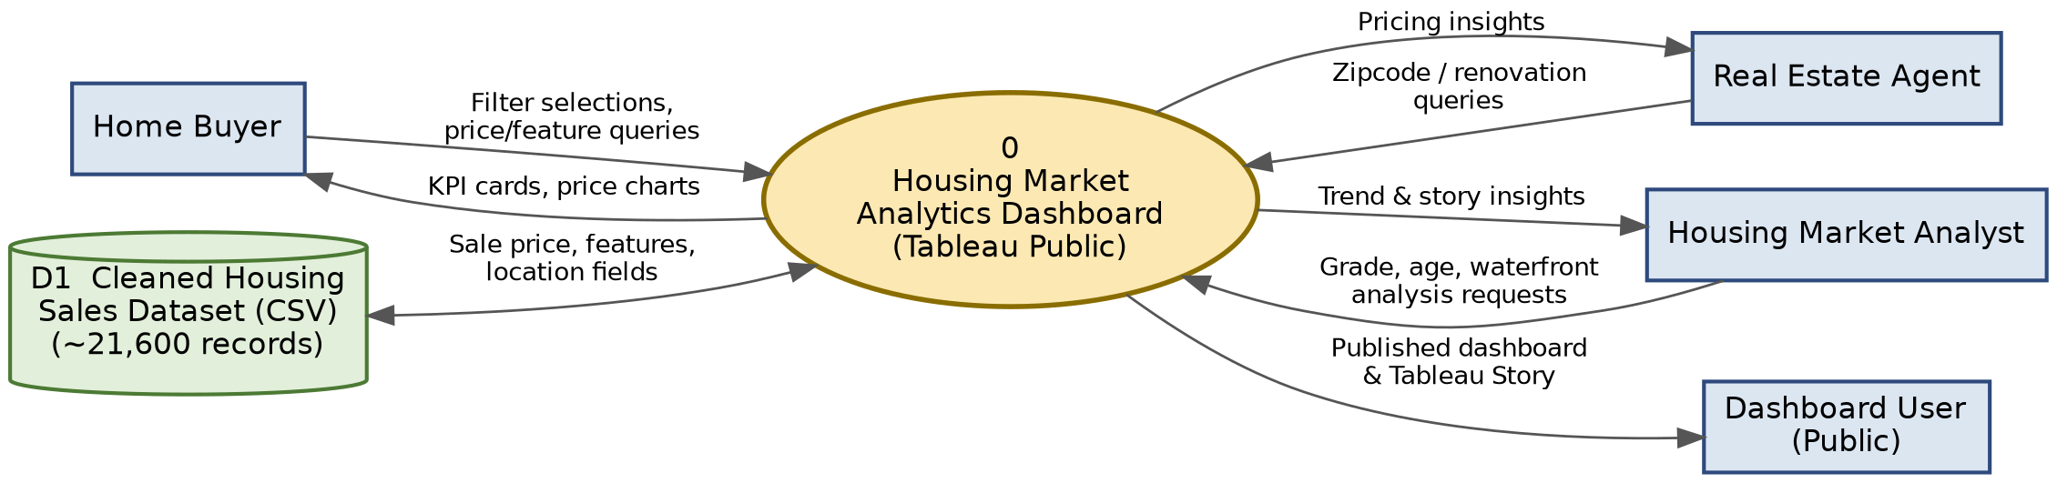
DFD Level 1 — Process Breakdown
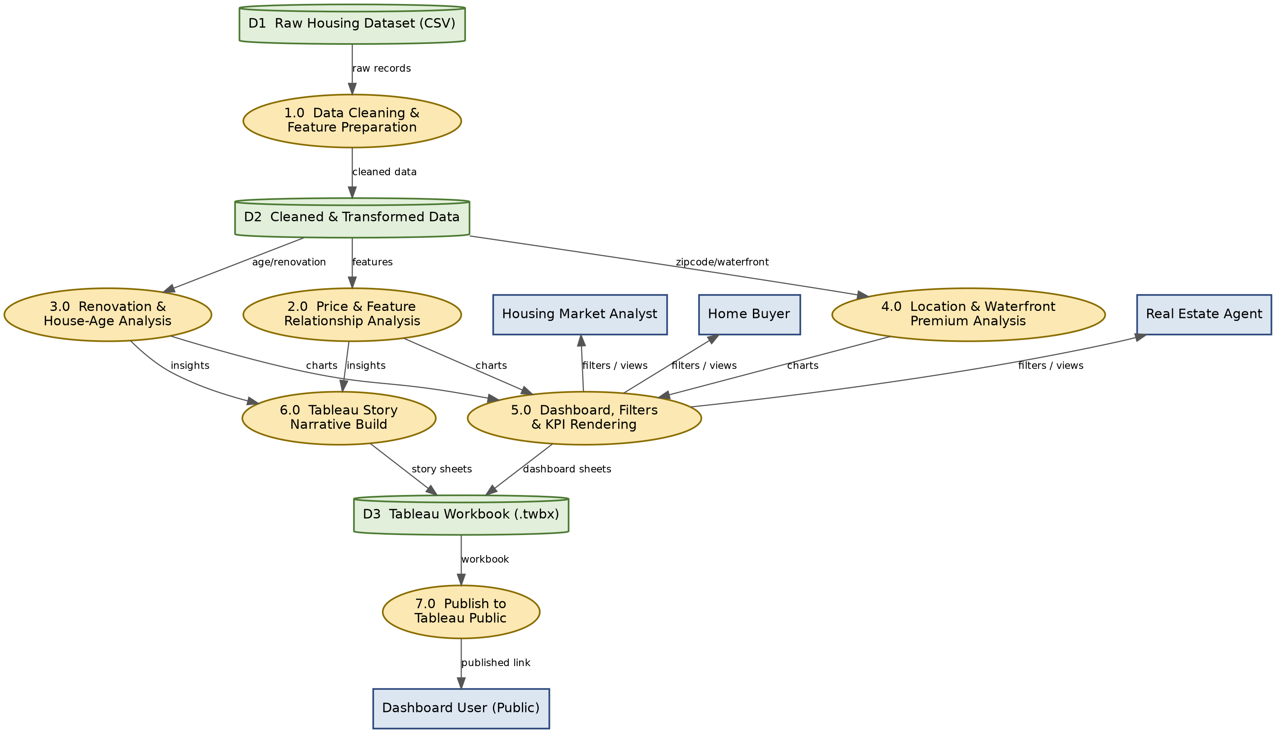
User Stories:
User Type | Epic | USN # | User Story / Task | Priority | Release
Home Buyer | KPI Dashboard | USN-1 | View key KPIs (total properties, avg. sale price, total living area) to gauge overall market conditions. | High | Sprint-1
Home Buyer | Interactive Filters | USN-2 | Filter listings by zipcode group and price range to focus on preferred homes. | High | Sprint-1
Home Buyer | Price & Feature Analysis | USN-3 | See how sale price varies with bedrooms and bathrooms to judge fair pricing. | Medium | Sprint-2
Real Estate Agent | Renovation Impact Analysis | USN-4 | Analyse how renovation status and years since renovation affect sale price. | High | Sprint-2
Real Estate Agent | Location-wise Price Analysis | USN-5 | Compare price trends across zipcode groups to recommend competitive listing prices. | Medium | Sprint-2
Real Estate Agent | House Age Analysis | USN-6 | View house-age distribution by bedrooms, bathrooms and floors. | Medium | Sprint-3
Housing Market Analyst | Price & Feature Relationship | USN-7 | Explore the grade/condition-vs-sale-price relationship to quantify how quality drives value. | High | Sprint-1
Housing Market Analyst | Waterfront & View Premium | USN-8 | Analyse the waterfront-view premium's impact on sale price. | Medium | Sprint-3
Housing Market Analyst | Tableau Story | USN-9 | Walk through a guided Tableau Story summarising key housing findings. | Medium | Sprint-3
Housing Market Analyst | Renovation Impact Analysis | USN-10 | Track total sales by years since renovation to identify how recency of renovation influences market activity. | High | Sprint-1
Housing Market Analyst | Interactive Filters | USN-11 | Use interactive filters for bedrooms, bathrooms and zipcode group to drill into market segments. | High | Sprint-1
Dashboard User | Public Access & Sharing | USN-12 | Access the published dashboard and story via Tableau Public without installing software. | High | Sprint-1
Dashboard User | Dashboard Visualization | USN-13 | Navigate a clear dashboard layout without confusion. | Medium | Sprint-2
Dashboard User | Interactive Filters | USN-14 | Reset all filters with a single action to return to the default view. | Low | Sprint-2
3.4 Technology Stack
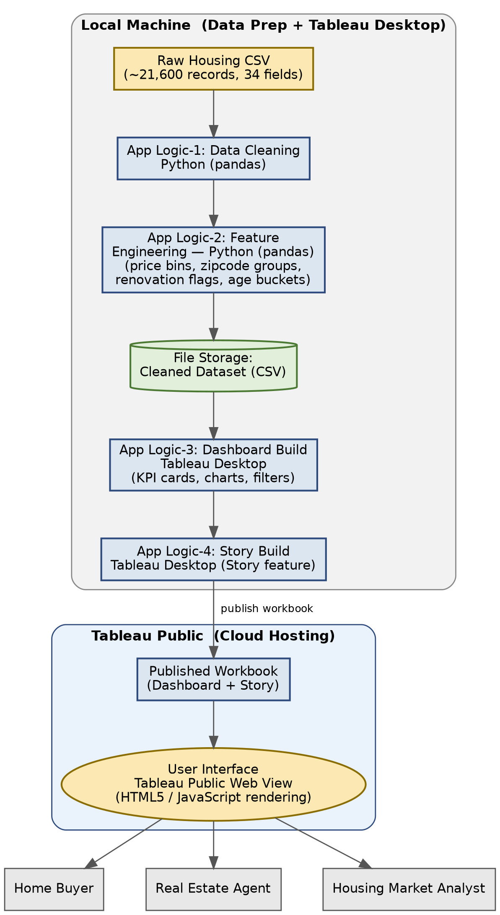
Visualizing Housing Market Trends — Architecture Flow
Table 1: Components & Technologies
S.No | Component | Description | Technology
1 | User Interface | How users view housing market insights, directly through the published Tableau Public dashboard and story in a web browser | Tableau Public (Web-based Interactive View), HTML5 / JavaScript
2 | Application Logic-1 | Cleans and prepares the raw housing CSV dataset prior to visualization (handling missing values, formatting fields, etc.) | Python (pandas)
3 | Application Logic-2 | Transforms prepared data into engineered features used by the dashboard (sale-price bins, zipcode grouping, renovation flags, age buckets) | Python (pandas)
4 | Application Logic-3 | Builds the interactive KPI cards, charts and filters that make up the housing dashboard | Tableau Desktop
5 | Application Logic-4 | Builds the guided Tableau Story narrating key housing-market insights | Tableau Desktop (Story feature)
6 | Database | This project does not use a traditional database; data is sourced directly from a CSV file | Not Applicable
7 | File Storage | Storage of the raw and cleaned/transformed housing dataset used to build the dashboard | Local File System (CSV)
8 | Machine Learning Model | Not used in the current scope; predictive price modelling was identified as future scope | Not Applicable
9 | Infrastructure (Server / Cloud) | Dashboard and story published directly to Tableau Public (no dedicated server or custom website); local system used for data cleaning and Tableau Desktop workbook development | Local Machine + Tableau Public
Table 2: Application Characteristics
S.No | Characteristic | Description | Technology
1 | Open-Source Frameworks | Open-source Python libraries used for data cleaning and feature preparation | pandas, NumPy
2 | Security Implementations | Public Tableau dashboard exposes only aggregated, anonymised property features; no personally identifiable buyer or seller information is published | Tableau Public access settings
3 | Scalable Architecture | Additional worksheets, dashboards, or datasets can be added to the Tableau Public workbook without restructuring the overall project | Modular Tableau workbook structure
4 | Availability | Dashboard and story remain accessible anytime via the Tableau Public link, with no dependency on a dedicated hosting server | Tableau Public hosting
5 | Performance | Optimised visualisations using pre-aggregated fields (sale-price bins, zipcode groups) and filtered extracts for fast load and filter response | Tableau Public rendering optimisation
4. PROJECT DESIGN
4.1 Problem – Solution Fit
The problem-solution fit maps the pains identified in the Empathy Map and Problem Statements directly onto the capabilities delivered by the Tableau dashboard and story, confirming that the proposed solution directly addresses the target users' core difficulty — judging whether a house's price is fair — without requiring them to manually cross-reference thousands of records.
Element | Description
Customer Segments | Home buyers, real estate agents, and housing market analysts evaluating residential property listings.
Problem | Difficulty judging whether a house's asking price genuinely reflects its size, condition, age and location, due to raw sales data being spread across thousands of records with dozens of features.
Existing Alternatives | Manual, listing-by-listing comparison; generic real-estate portals showing individual listings without aggregated market context; static spreadsheet analysis.
Proposed Solution | An interactive Tableau Dashboard and guided Tableau Story, built on ~21,600 cleaned sales records, that visualise how price relates to features, renovation, age, location and waterfront view.
Unique Value Proposition | A single, freely accessible, filterable view (no custom app or hosting needed) that turns thousands of raw property records into clear, comparable, data-backed pricing insight.
Early Adopters | Housing market analysts and real estate agents already comparing sale prices manually across listings, who are the most motivated to adopt a faster, visual alternative.
4.2 Proposed Solution
S.No | Parameter | Description
1. | Problem Statement | Home buyers, sellers and real estate agents lack a structured way to judge whether a house's asking price genuinely reflects its size, condition, age and location. Historical sales data is spread across thousands of property records with dozens of features, making manual analysis difficult and leaving pricing, buying and selling decisions largely based on guesswork rather than data-driven evidence.
2. | Idea / Solution Description | The proposed solution uses a housing sales dataset of approximately 21,600 records to build an interactive Tableau Dashboard and Tableau Story analysing how sale price relates to house features (bedrooms, bathrooms, living area, overall grade), renovation status and house age, location (zipcode group), and waterfront view. The dashboard and story are published directly to Tableau Public, giving stakeholders a single, openly accessible interface to explore price-driving patterns through interactive filters.
3. | Novelty / Uniqueness | Rather than static price reports, the solution offers an interactive Tableau Dashboard with drill-down filters (zipcode group, bedrooms, bathrooms, price range) alongside a guided Tableau Story that narrates renovation, house-age and bedroom-driven insights in sequence. Publishing directly to Tableau Public removes the need for any custom web application or hosting infrastructure.
4. | Social Impact / Customer Satisfaction | Home buyers gain confidence that a listed price genuinely reflects a home's features, condition and location, while real estate agents and analysts can back their pricing and valuation recommendations with data rather than guesswork, supporting fairer, more informed decisions across the housing market.
5. | Business Model (Revenue Model) | The dashboard can be offered as a free public resource to build trust and visibility, with revenue generated through premium services such as custom dashboards for brokerages, region-specific market reports, and consulting engagements.
6. | Scalability of the Solution | The solution can be extended with additional datasets covering new cities, zipcode groups or time periods, and can incorporate predictive price modelling as future scope. Additional dashboards and story points can be added to the existing Tableau workbook without restructuring the overall project.
4.3 Solution Architecture
Solution architecture bridges the gap between the business problem and the technology solution — defining the structure, features, development phases and requirements according to which the solution is specified, managed and delivered.
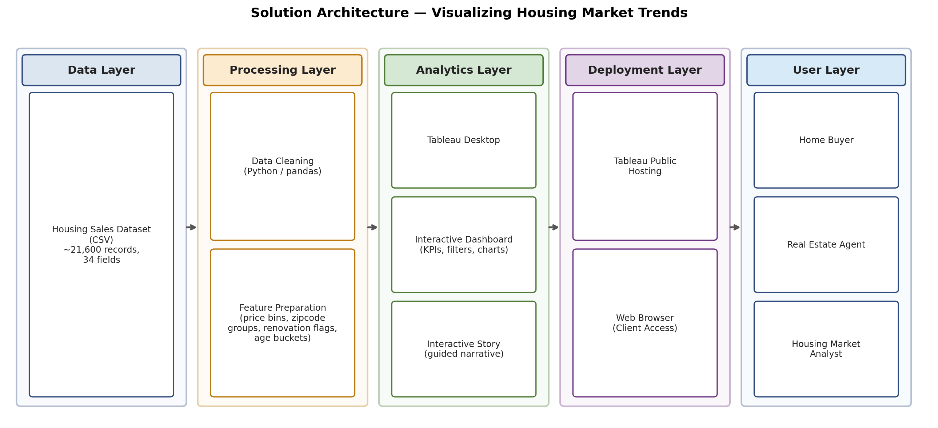
Architecture and data flow of the Visualizing Housing Market Trends analytics application
5. PROJECT PLANNING & SCHEDULING
5.1 Project Planning
Product Backlog & Sprint Schedule:
Sprint | Epic | USN # | User Story / Task | SP | Priority | Owner
Sprint-1 | Data Collection & Preparation | USN-1 | Collect housing sales dataset (sale price, bedrooms, bathrooms, living area, lot area, floors, age, renovation status, waterfront view, zipcode group). | 3 | High | Masa Nani
Sprint-1 |  | USN-2 | Clean and standardise raw data, handling missing or inconsistent values. | 5 | High | Masa Nani
Sprint-1 |  | USN-3 | Prepare and transform data (price bins, zipcode grouping, renovation flags, age buckets). | 5 | High | Masa Nani
Sprint-1 |  | USN-4 | Validate the cleaned and transformed dataset. | 3 | Medium | Gabbi Nithya Sree
Sprint-2 | Tableau Dashboard | USN-5 | Build KPI dashboard (total properties, average sale price, total living/basement area). | 5 | High | Masa Nani
Sprint-2 |  | USN-6 | Price & feature relationship analysis (bedrooms, bathrooms, living area vs. sale price). | 5 | High | Gabbi Nithya Sree
Sprint-2 |  | USN-7 | Overall grade / condition vs. sale price comparison. | 3 | High | Gabbi Nithya Sree
Sprint-2 |  | USN-8 | Build interactive filters (zipcode group, bedrooms, bathrooms, price range). | 3 | Medium | Masa Nani
Sprint-3 | Insights | USN-9 | Renovation impact analysis (sales by years since renovation, age by renovation status). | 5 | High | Gabbi Nithya Sree
Sprint-3 |  | USN-10 | House-age distribution analysis by bedrooms, bathrooms and floors. | 5 | Medium | Masa Nani
Sprint-3 |  | USN-11 | Location-wise price analysis by zipcode group. | 3 | High | Gabbi Nithya Sree
Sprint-3 |  | USN-12 | Waterfront & view premium analysis. | 3 | Medium | Masa Nani
Sprint-4 | Deployment | USN-13 | Build guided Tableau Story narrating key housing-market insights. | 5 | High | Gabbi Nithya Sree
Sprint-4 |  | USN-14 | Publish dashboard and story to Tableau Public. | 3 | High | Masa Nani
Sprint-4 |  | USN-15 | Testing (verify dashboard accuracy, filter behaviour and story flow). | 3 | High | Gabbi Nithya Sree
Sprint-4 |  | USN-16 | Documentation. | 2 | High | Masa Nani
Sprint Tracker:
Sprint | Total SP | Duration | Start Date | Planned End | SP Completed | Actual Release
Sprint-1 | 16 | 7 Days | 20 Jul 2026 | 26 Jul 2026 | 16 | 26 Jul 2026
Sprint-2 | 16 | 7 Days | 27 Jul 2026 | 02 Aug 2026 | 16 | 02 Aug 2026
Sprint-3 | 16 | 7 Days | 03 Aug 2026 | 09 Aug 2026 | 16 | 09 Aug 2026
Sprint-4 | 13 | 7 Days | 10 Aug 2026 | 16 Aug 2026 | 13 | 16 Aug 2026
Velocity: Across the 4 sprints, the team completed a total of 61 story points, giving an average velocity of 61 / 4 = 15.25 story points per sprint.
Burndown Chart:
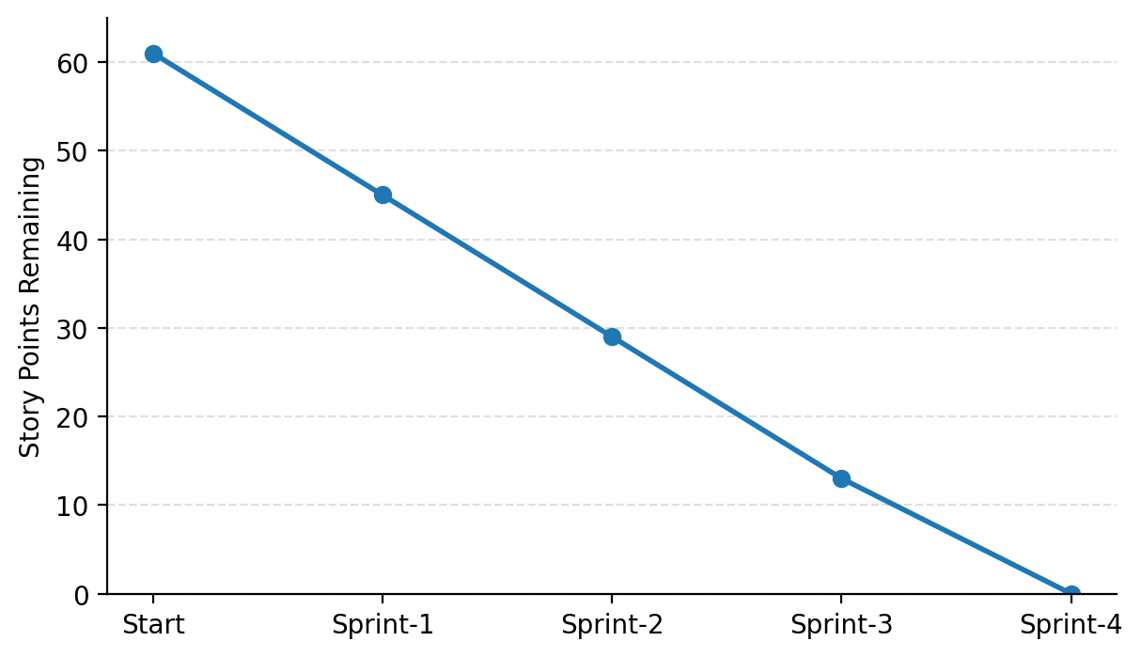
6. FUNCTIONAL AND PERFORMANCE TESTING
Functional testing was carried out against the acceptance criteria defined for each user story (Section 3.3) — verifying that KPI cards display accurate totals on load, that filters update all dependent charts without a page reload, and that story points navigate correctly in sequence. All user stories passed their defined acceptance criteria.
6.1 Performance Testing
S.No | Parameter | Screenshot / Values
1 | Data Rendered | The housing dataset (Transformed_Housing_Data2.csv, ~21,609 records, 31 fields) was successfully uploaded and rendered in Tableau Public. All dataset fields — Sale Price, Bedrooms, Bathrooms, Flat Area, Lot Area, Floors, Overall Grade, Basement Area, Age of House, Years Since Renovation, Condition of the House, Ever Renovated and Zipcode Group — were loaded correctly.
2 | Data Preprocessing | Removed null values, verified data types, removed duplicate property records, created calculated fields (House Age, Years Since Renovation, Ever Renovated Yes, Sale Price bins), grouped Zipcode (1–9), and validated renovation and condition fields before visualization.  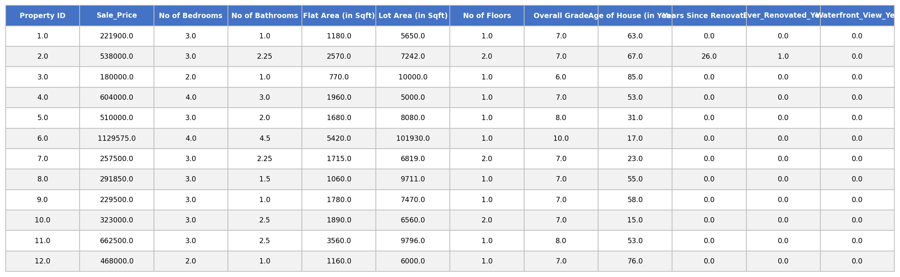  Cleaned and transformed housing dataset used for dashboard visualization
3 | Utilization of Filters | Filters used: Zipcode Group (1–9), Age of House (in Years), Sale Price (bin), No of Bedrooms, No of Bathrooms and Measure Names.  Aggregation functions: SUM(Sale Price) and CNT(Sale Price) drive the KPI totals; AVG(Sale Price) drives the Avg. Sale Price KPI; SUM(Ever Renovated Yes) drives the renovation-status pie chart; SUM(No of Bedrooms/Bathrooms/Floors) drive the age-distribution chart. Coordinated filters keep the KPI cards, renovation-impact chart and age-distribution chart in sync across the dashboard.
4 | Calculation Fields Used | Calculated fields: House Age, Years Since Renovation, Ever Renovated Yes, Sale Price (bin) and Zipcode Group — enabling the KPI cards and breakdown charts to aggregate correctly without requiring raw row-level detail.
5 | Dashboard Design | 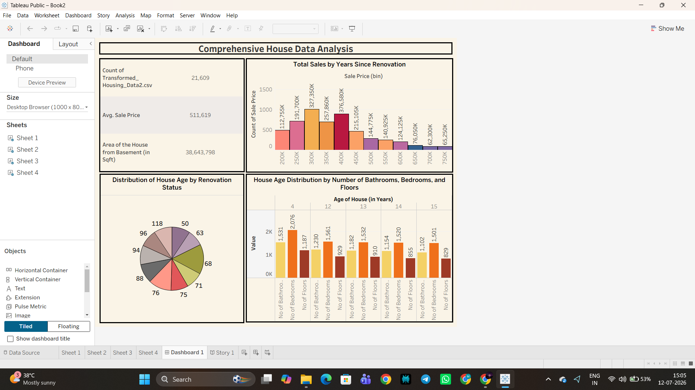  Comprehensive House Data Analysis — Tableau Public Dashboard
6 | Story Design | Multiple story points were created to narrate the housing-market findings in sequence: the importance of recent renovations in boosting property sales, how house age varies by renovation status, and how house-age distribution is influenced by number of bedrooms.  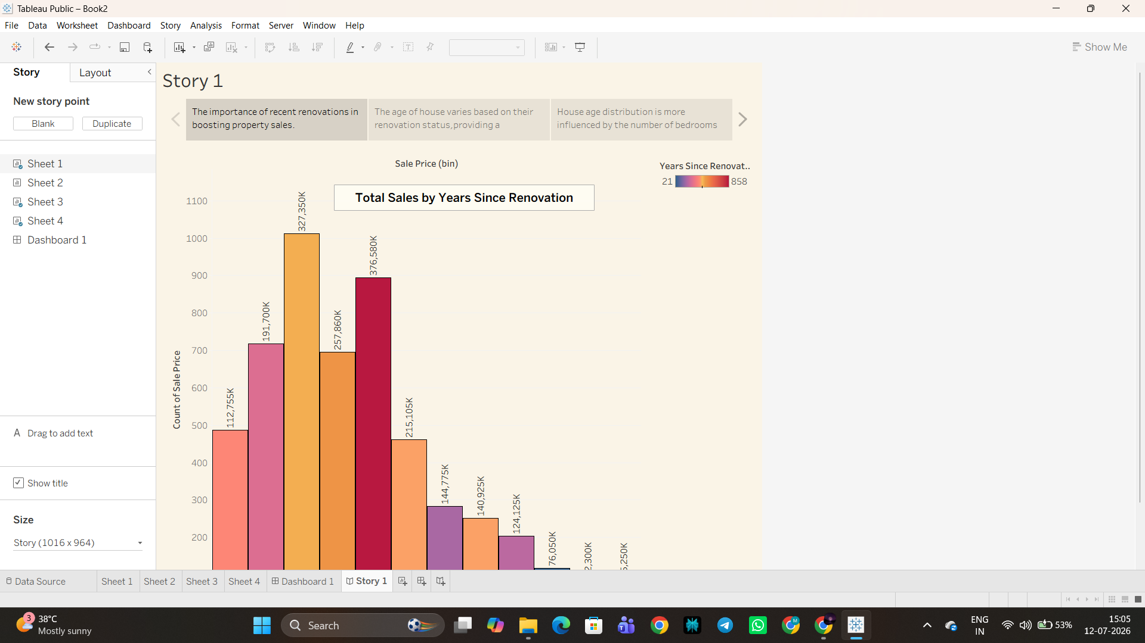  Story Point — House Age Distribution by Bathrooms, Bedrooms and Floors
7. RESULTS
7.1 Output Screenshots
Comprehensive House Data Analysis Dashboard:

Sheet 1 — Total Sales by Years Since Renovation:
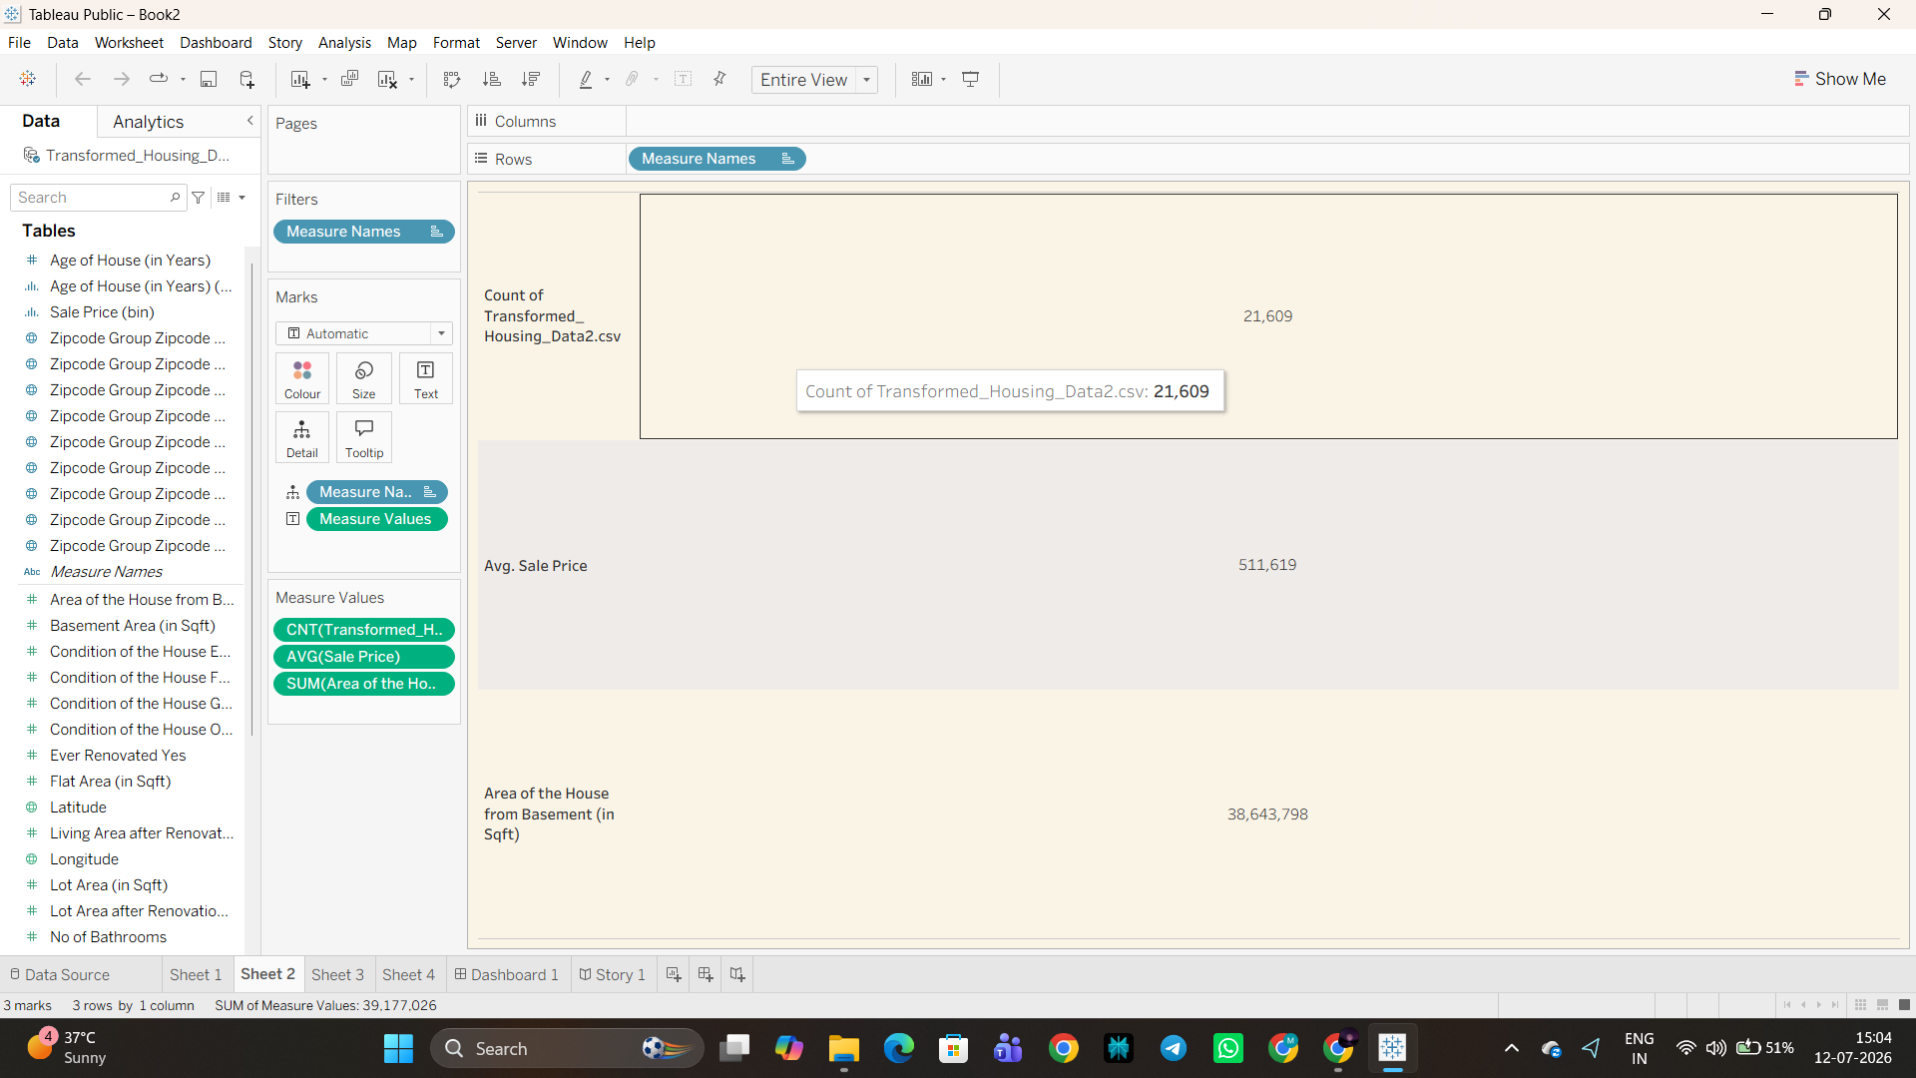
Sheet 2 — KPI Summary Panel:
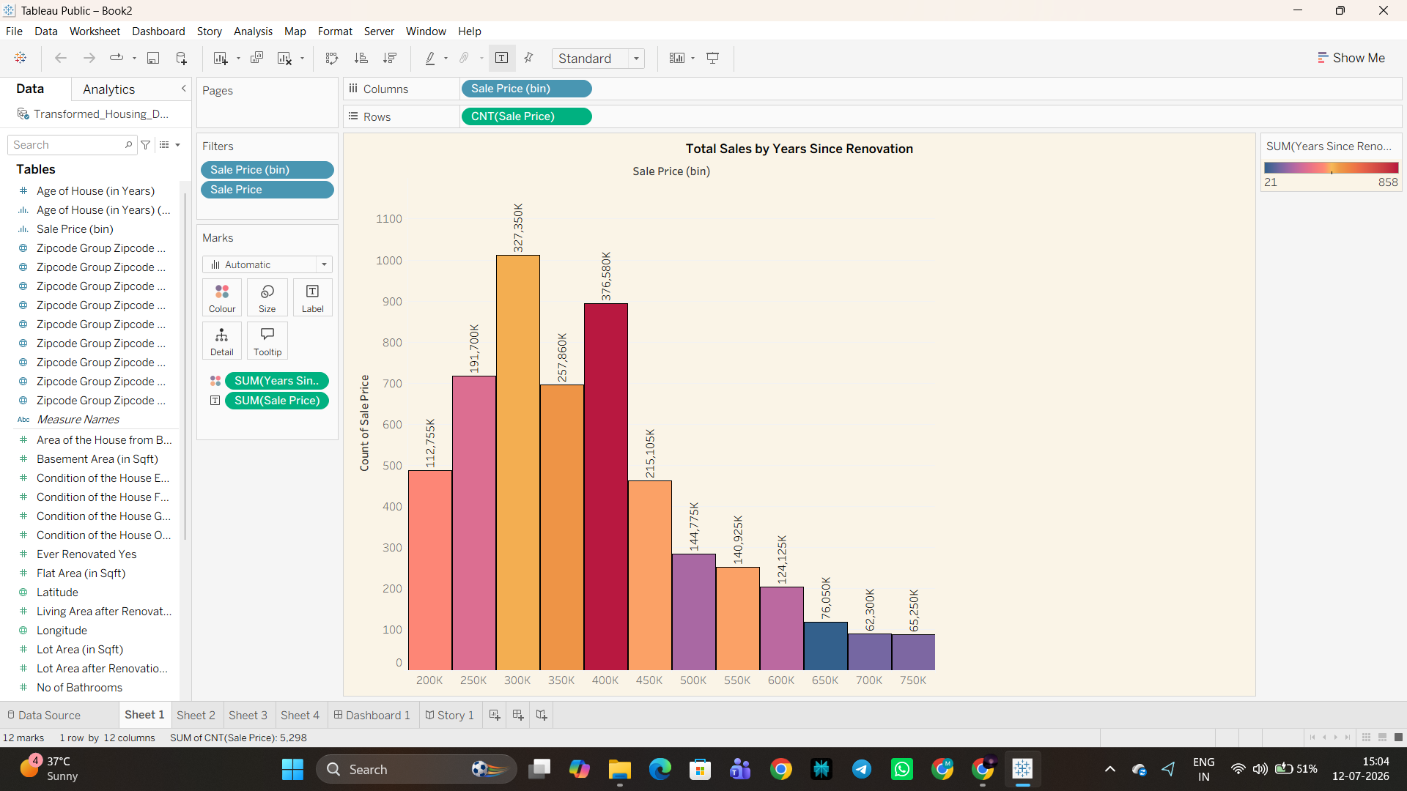
Sheet 3 — Distribution of House Age by Renovation Status:
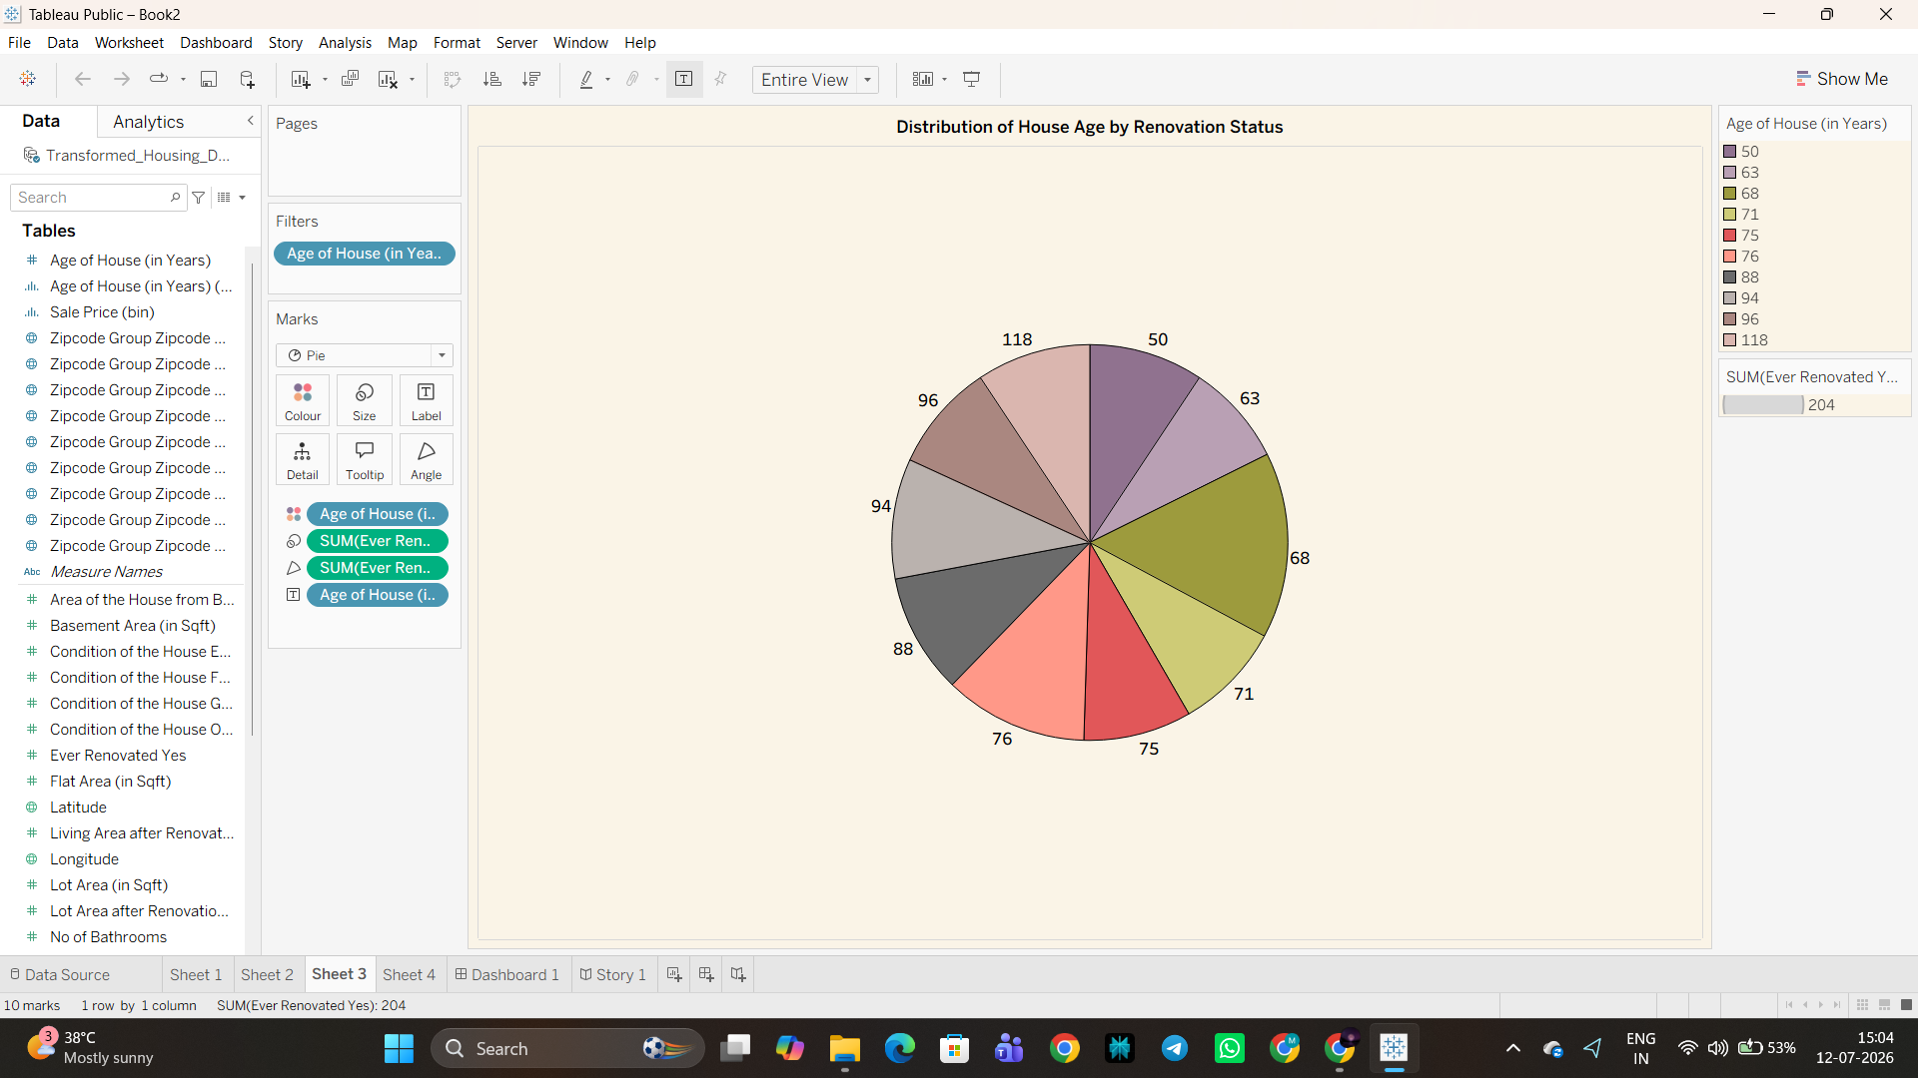
Sheet 4 — House Age Distribution by Bathrooms, Bedrooms and Floors:
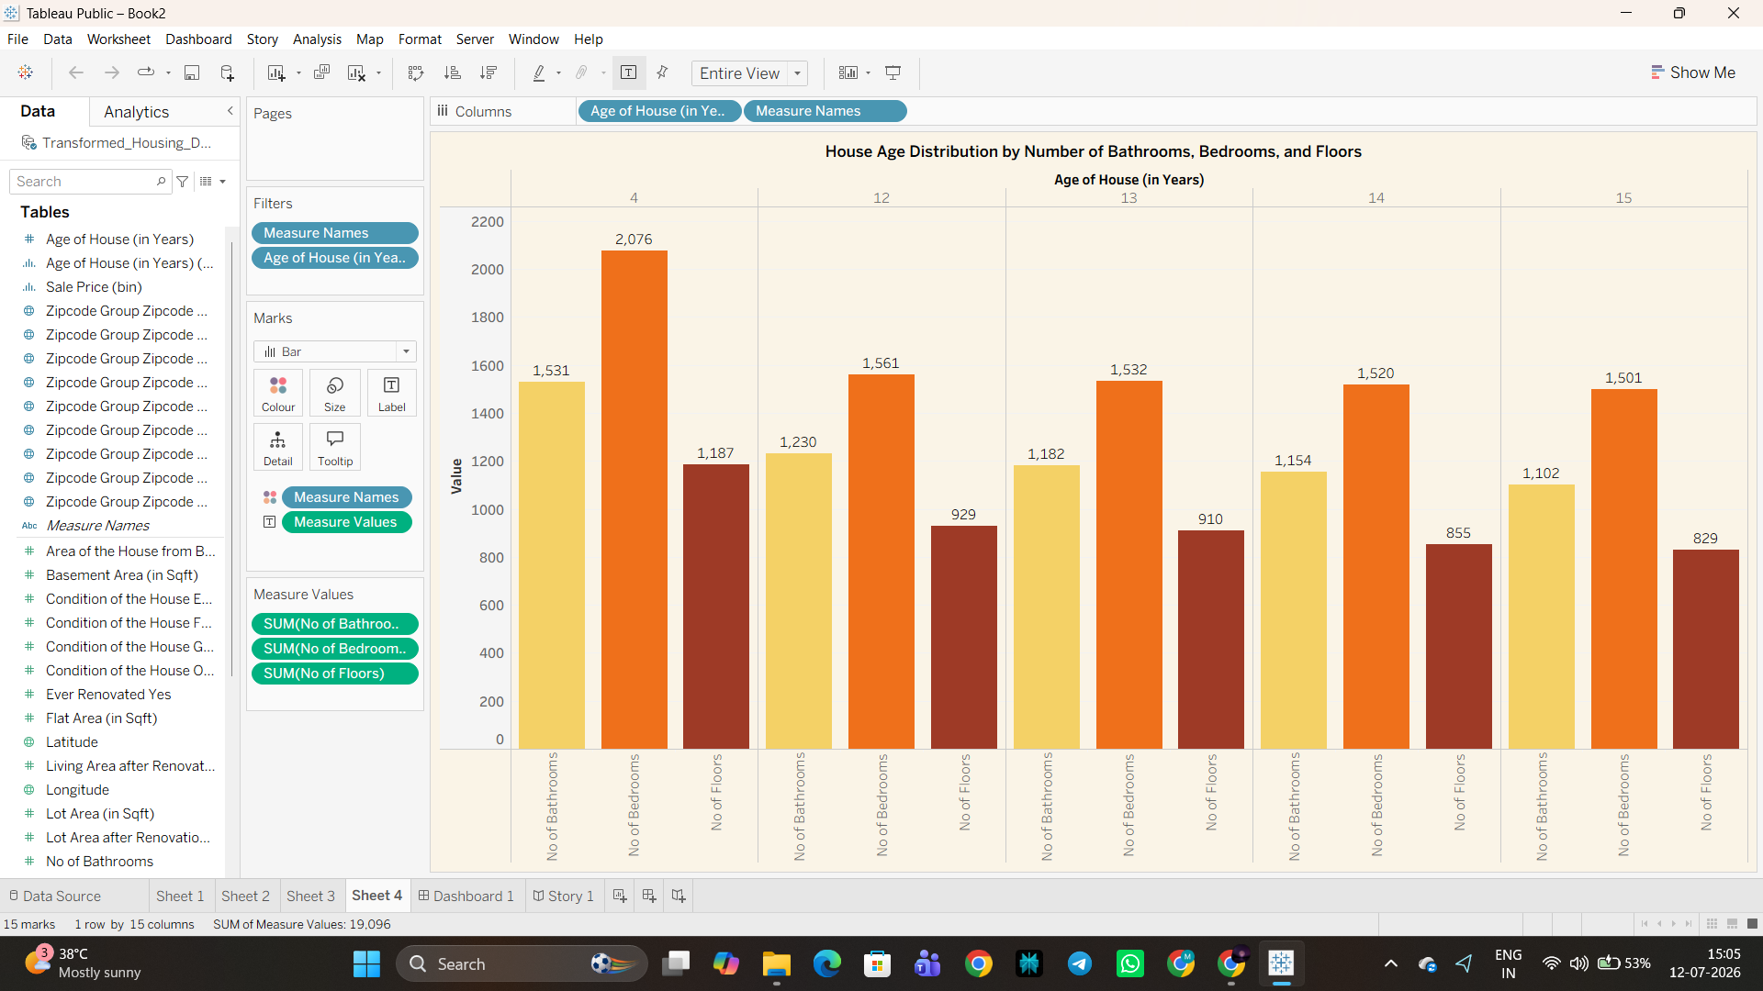
Story Point 1:

Story Point 2:
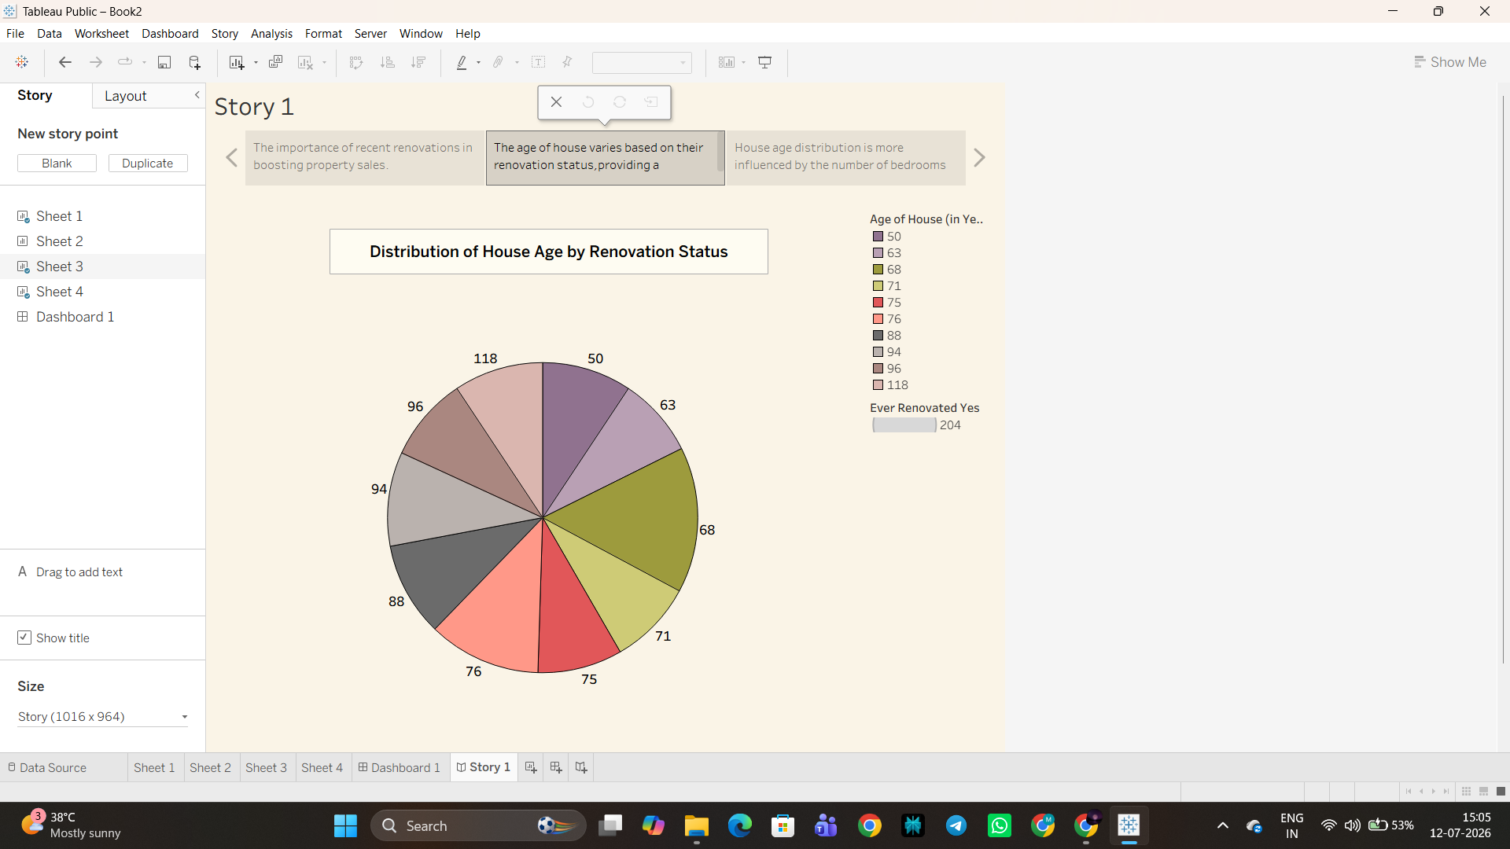
Story Point 3:
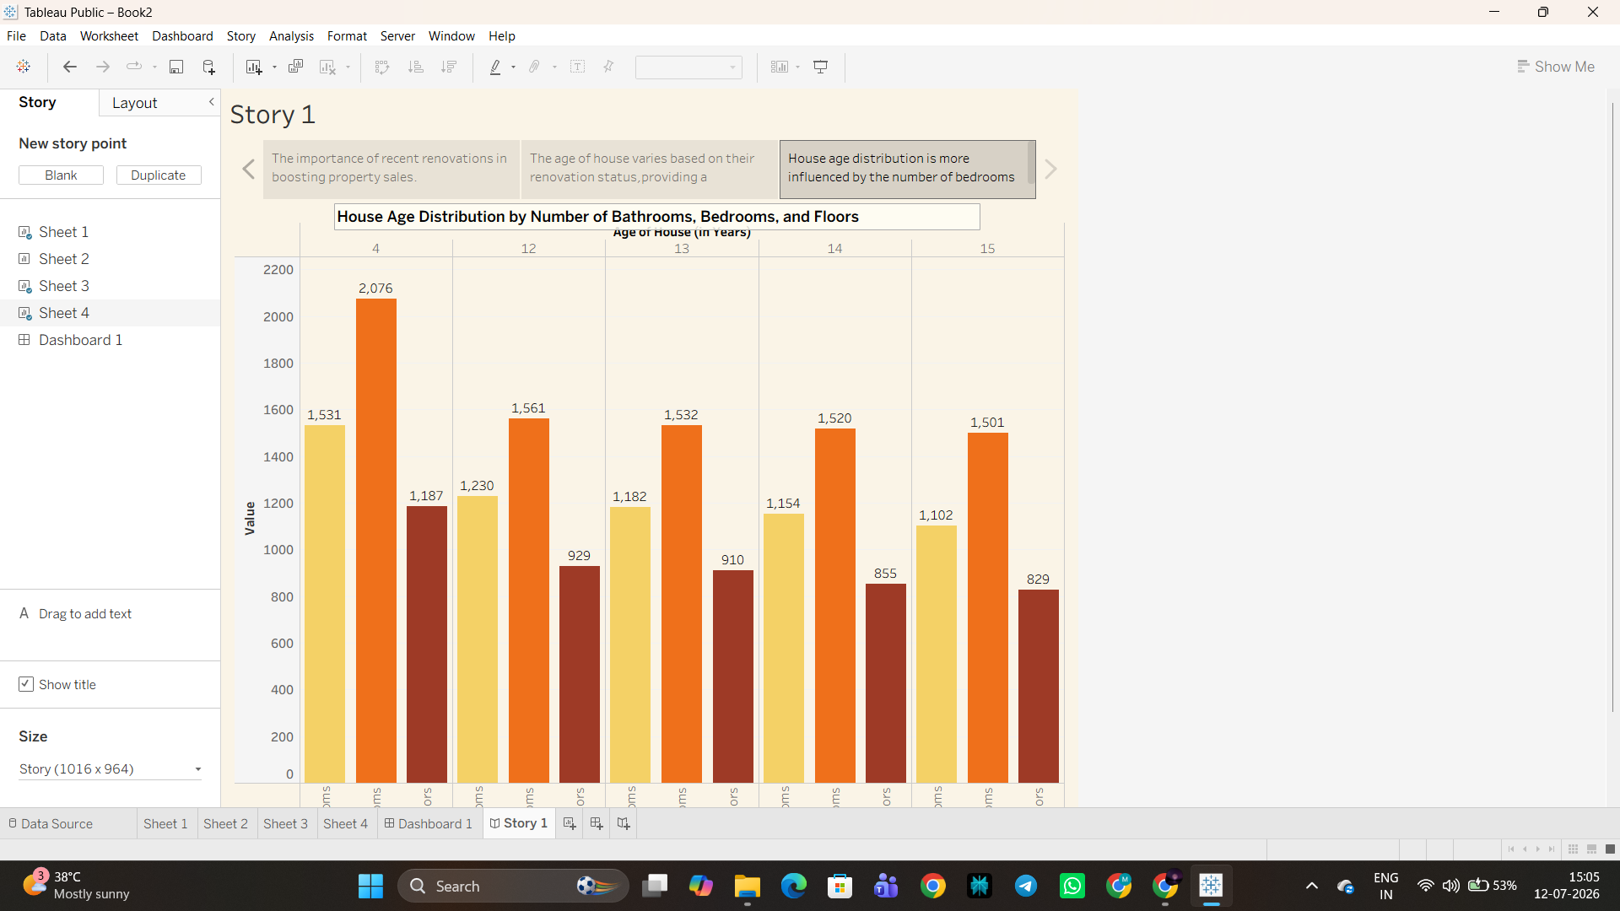
8. ADVANTAGES & DISADVANTAGES
Advantages:
- Turns ~21,600 raw property records into a single interactive dashboard, removing the need for manual, listing-by-listing comparison.
- Interactive filters (zipcode group, bedrooms, bathrooms, price range) let each stakeholder drill into the segment relevant to them.
- Published directly to Tableau Public, so there is no hosting cost or custom infrastructure to maintain.
- The guided Tableau Story makes renovation, age and location insights accessible to non-technical stakeholders.
- Only aggregated, non-identifiable property features are published, keeping buyer/seller data private.
- Modular Tableau workbook structure allows new datasets, cities or story points to be added without restructuring the project.
Disadvantages:
- The solution is descriptive/historical only — it does not include predictive price modelling.
- Tableau Public dashboards are visible to anyone with the link, offering no user-level access control.
- The dataset is static; refreshing it with new sales data requires a manual re-publish rather than a live feed.
- Analysis is limited to the fields present in the dataset — external factors such as interest rates or local school ratings are not captured.
- Very large data extracts can affect load and filter-response performance on the free tier of Tableau Public.
9. CONCLUSION
This project set out to help home buyers, real estate agents and housing market analysts judge whether a house's asking price genuinely reflects its size, condition, age and location — a task that was previously difficult given ~21,600 records spread across 34 raw fields. By cleaning and transforming the dataset and building an interactive Tableau Dashboard alongside a guided Tableau Story, the project delivers a single, freely accessible view of how sale price relates to bedrooms, bathrooms, living area, overall grade, renovation status, house age, waterfront view and location (zipcode group).
The completed “Comprehensive House Data Analysis” dashboard — published on Tableau Public — successfully meets the functional requirements defined during the design phase, passed all acceptance criteria during functional and performance testing, and gives stakeholders the confidence to make pricing, buying and selling decisions backed by data rather than guesswork.
10. FUTURE SCOPE
- Predictive Price Modelling: incorporate a regression or machine-learning model to forecast sale prices once a longer time-series dataset is available (identified as “Plan Next” during idea prioritization).
- Geographic expansion: extend the dataset to additional cities, zipcode groups or regions beyond the current market.
- Automated data refresh: connect the dashboard to a live or periodically refreshed data source instead of a static CSV extract.
- Number-of-visits engagement analysis: revisit the “Reconsider” idea of tracking listing visit counts as an additional demand signal.
- Mobile-optimised dashboard layout for on-the-go access by agents and buyers.
- Exportable insight summaries so users can save or share key findings outside of Tableau Public.
11. APPENDIX
Source Code:
No custom application source code was developed, as the solution is delivered entirely through Tableau Public. Data cleaning and feature engineering (handling missing values, removing duplicates, creating calculated fields such as House Age, Years Since Renovation, and Zipcode Group) were performed prior to visualization using Python (pandas) — see Section 3.4 (Technology Stack) and the Project Development Phase documentation for the detailed preprocessing steps.
[ Insert preprocessing script / notebook link here ]
Dataset Link:
[ Insert dataset link here ]
GitHub Repository Link:
[ Insert GitHub repository link here ]
Project Demo Link (Tableau Public):
[ Insert Tableau Public dashboard / story demo link here ]

